Current Employee Opal
card renewal
Fact sheet & QAs – August 2021

All Employee Opal cards are expiring and replacement cards are currently being distributed.

Overview
Employees of relevant agencies that hold Employee Opal cards are currently having their Opal card renewed. This is because the life of the card (5 years) is coming to an end.
We are in the process of renewing all current Employee Opal cards and are requesting card holders refresh their contact details with us as part of this process.
Grey cards will be replaced by a blue card for transport based employees. The replacement card will be valid for two years.

If an employee’s card has expired and they have not received their replacement card yet, they will be able to use their current grey Employee Opal card as a flash pass for a period of time.

Q&As for card holders

What is happening about the renewal of my Employee Opal card?
It is now coming up to 5 years since the Employee Opal card was launched and this means that many cards are expiring and will need to be replaced. We have asked current card holders to validate their personal details so replacement cards can be issued.

When will my Employee Opal card be renewed?
Cards are currently being sent out and will begin to arrive soon.

How will I receive my new card?
Sydney Trains, NSW TrainLink and former employees will have your card sent directly to you (a valid Australia Post address). For other Employee Opal card holders, your card will sent to your issuing agency. If you have not received your new card by early September, please log a query via https://transportnsw.info/contact-us/feedback/fares-concessions-tickets-feedback

Is there a pass I can use while I am waiting for my replacement pass?
Yes. If your grey Employee Opal card stops working, you can use it as a flash pass while you wait for your new card.

Why is the new Employee Opal card only valid for only two years?
The card is valid for two years to ensure it is replaced more regularly and aligned with current eligibility.

Will my travel benefits change with the new card?
No. The benefits of your Employee Opal card remain the same with your renewed card. It is just a different colour.
If the benefits printed on the back of your new card are not the same as your current benefits, please log a query via https://transportnsw.info/contact-us/feedback/fares-concessions-tickets-feedback

Why does the letter that came with my new Employee Opal card not include all my previous travel benefits and entitlements?
The standard letter that will accompany your new card may include some outdated information. To make sure we get your card to you as soon as possible, we are sending them with the current letter rather than delaying the issuing of cards to update it.

Please be assured that your travel pass entitlements have not changed and you will be able to continue to use your new Employee Opal card to access all your current services.

If the benefits printed on the back of your new card are not the same as your current benefits, please log a query via https://transportnsw.info/contact-us/feedback/fares-concessions-tickets-feedback

What should I do with my current Employee Opal card when I get my new Employee Opal card?
Please destroy your old Employee Opal card.

What is the secure online form and how will it be used?

We are requesting eligible Employee Opal card holders to update their details online through a secure online form (below) so we can issue you a replacement card and contact you with any future products and services. https://concessions.transport.nsw.gov.au/

What information needs to be populated into the secure online form?

Address, email and phone number need to either be validated or updated on the form.

Will TfNSW use the information for any other purposes?

Contact details are used for any notifications that need to be sent to you as a card holder, such as delivery updates, issues or product changes.

How secure is the online form?

The online form is a secure interface compliant with the highest level of security.

Where can I use my Employee Opal card?

Usage of your new Employee Opal card is the same as your old card

Do I need to tap on and tap off?
Yes. It is important to use your Employee Opal card to tap on and tap off at an Opal card reader at stations, stops, on buses or at ferry wharves when travelling.

What should I do if I forget to tap off (for example at an ungated station)
It is a condition of use that you tap on and tap off on every trip with your Employee Opal card. If you forget as a once-off, don’t panic. However, repeated instances of failing to tap off may be reviewed and can constitute misuse of the pass.

What should I do if my new card is lost, stolen or damaged?

Employees and former employees can request a replacement card by logging a query via https://transportnsw.info/concessions-application
You can find the Employee Opal card terms of use here: https://transportnsw.info/document/2114/opal-terms-of-use.pdf

Are there any fees for card renewal, replacement, lost, stolen or damaged cards?
There are no fees for staff in Transport cluster agencies who are entitled to an Employee Opal card.
Charges may apply for non-Transport cluster card holders.

How long is the new Employee Opal card valid?
The new Employee Opal card is valid for two years. As long as your eligibility remains the same, you can reapply every two years for a new Employee Opal.

Do I need to travel with an Employee Opal card to prove my eligibility?
Yes. You must provide your card upon request which has your details printed on the back of the card.

What information is printed on the back of the card?
Your name and benefits are printed on your card, where applicable:
- Card holder name
- Valid to date
- Employee number or reference number
- Charge account/business unit
- Former employee (FORMER)
- Partner (PARTNR)
- Sydney Airport access fee (SAF) or concessional access fee (CONSAF)
- Agency code
- Sleeping berth (SLEEP)
- Private bus (PBO)

Privacy

How is employees’ personal information managed?
Transport for NSW (TfNSW) is committed to protecting the privacy of your personal information in accordance with the Privacy and Personal Information Protection Act 1998 (NSW).
The personal information provided by you, including through application and renewal forms for your free travel pass, is collected by TfNSW for the purposes of you obtaining a free travel pass and will continue to be held by TfNSW for the purposes of determining your eligibility for, and issuing and managing of, your travel entitlement and Employee Opal card.
So we can deal with your concession travel and Employee Opal card, TfNSW may share your information with other NSW Government Transport cluster agencies to validate your details and eligibility for an Employee Opal card.
Otherwise we will not disclose your personal information unless you consent, or we are permitted or required by law.
You can ask to access or amend your personal information held by us, by contacting TfNSW at privacy@transport.nsw.gov.au or Locked Bag 5085 Parramatta NSW 2124.
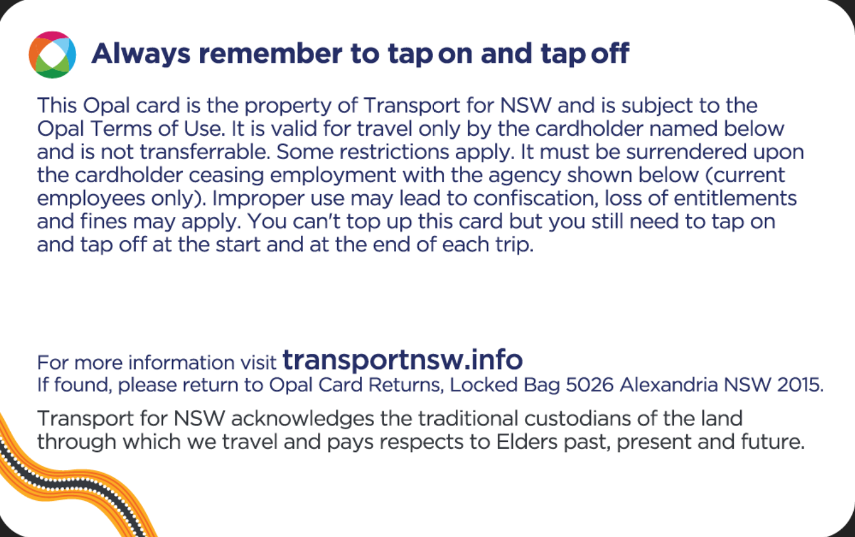
New Employee Opal Card

